Date:17/02/22

Lab session no:01

**Aim:**

a)Steps for installation of Andriod Studio

b) Android Virtual Device Creation

**Software’s /IDE Tools:**

Android Development Kit / Android Studio

**Code/Implementation:**

**a)Android Studio** is the official **IDE (Integrated Development Environment)** for Android app development and it is based on **JetBrains’ IntelliJ IDEA** software. Android Studio provides many excellent features that enhance productivity when building Android apps, such as:

* A blended environment where one can develop for all Android devices
* Apply Changes to push code and resource changes to the running app without restarting the app
* A flexible Gradle-based build system
* A fast and feature-rich emulator
* GitHub and Code template integration to assist you to develop common app features and import sample code
* Extensive testing tools and frameworks
* C++ and NDK support
* Built-in support for Google Cloud Platform, making it easy to integrate Google Cloud Messaging and App Engine, and many more.

**System Requirements**

* Microsoft Windows 7/8/10 (32-bit or 64-bit)
* 4 GB RAM minimum, 8 GB RAM recommended (plus 1 GB for the Android Emulator)
* 2 GB of available disk space minimum, 4 GB recommended (500 MB for IDE plus 1.5 GB for Android SDK and emulator system image)
* 1280 x 800 minimum screen resolution

### ****Installation Guide****

**Step 1:**Head over to [**this link**](https://developer.android.com/studio/#downloads) to get the Android Studio executable or zip file.

**Step 2:**Click on the **Download Android Studio** Button.

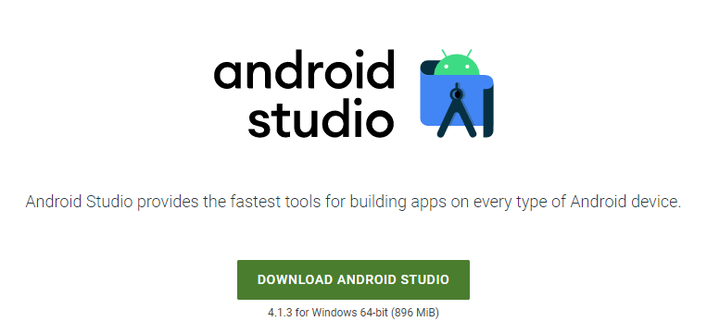

Click on the “I have read and agree with the above terms and conditions” checkbox followed by the download button.

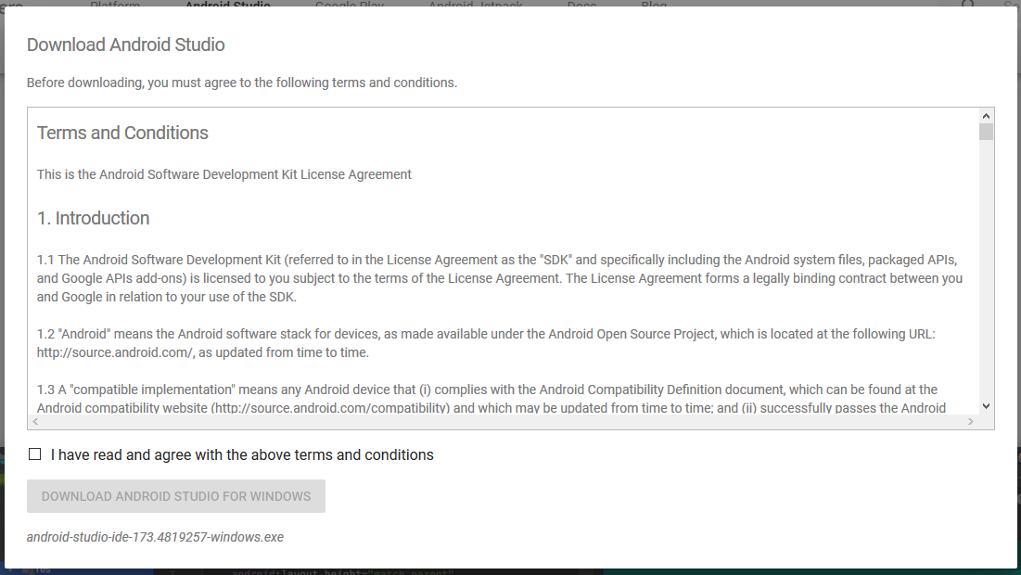

Click on the Save file button in the appeared prompt box and the file will start downloading.

**Step 3:**After the downloading has finished, open the file from downloads and run it. It will prompt the following dialog box.

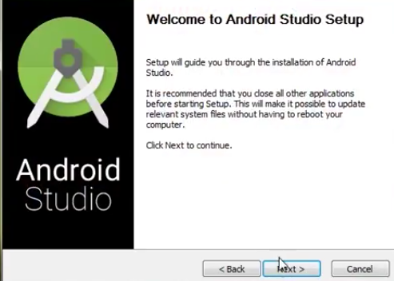

Click on next. In the next prompt, it’ll ask for a path for installation. Choose a path and hit next.

**Step 4:**It will start the installation, and once it is completed, it will be like the image shown below.

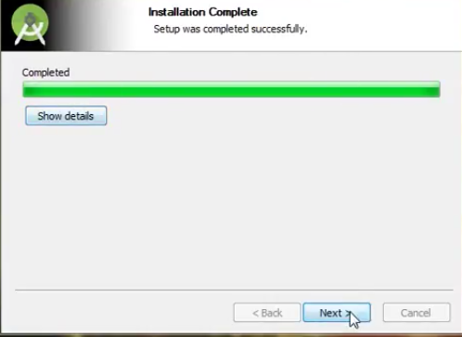

Click on next.

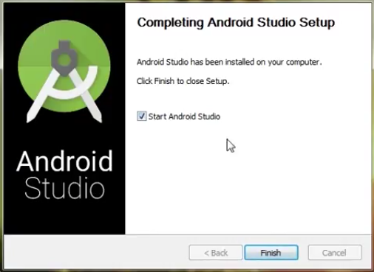

**Step 5:**Once “**Finish**” is clicked, it will ask whether the previous settings need to be imported [if the android studio had been installed earlier], or not. It is better to choose the ‘Don’t import Settings option’.

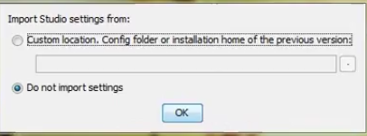

Click the **OK**button.

**Step 6:**This will start the Android Studio.

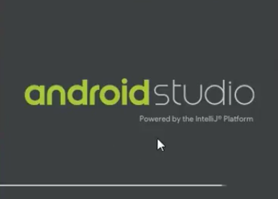

Meanwhile, it will be finding the available SDK components.

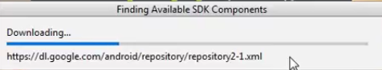

**Step 7:**After it has found the SDK components, it will redirect to the Welcome dialog box.

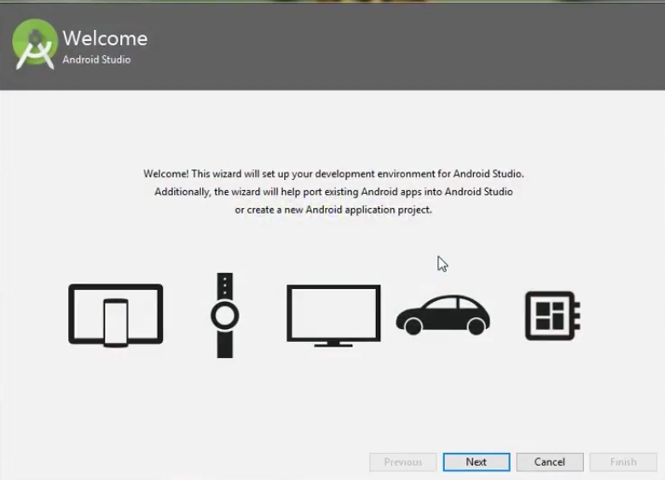

Click on **Next**.

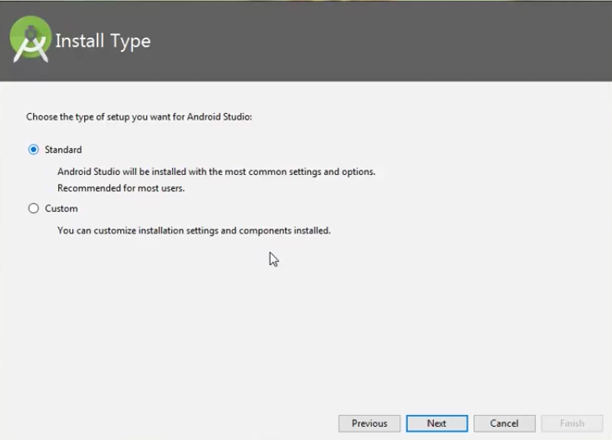

Choose Standard and click on Next. Now choose the theme, whether the **Light**theme or the **Dark**one. The light one is called the **IntelliJ**theme whereas the dark theme is called **Darcula**. Choose as required.

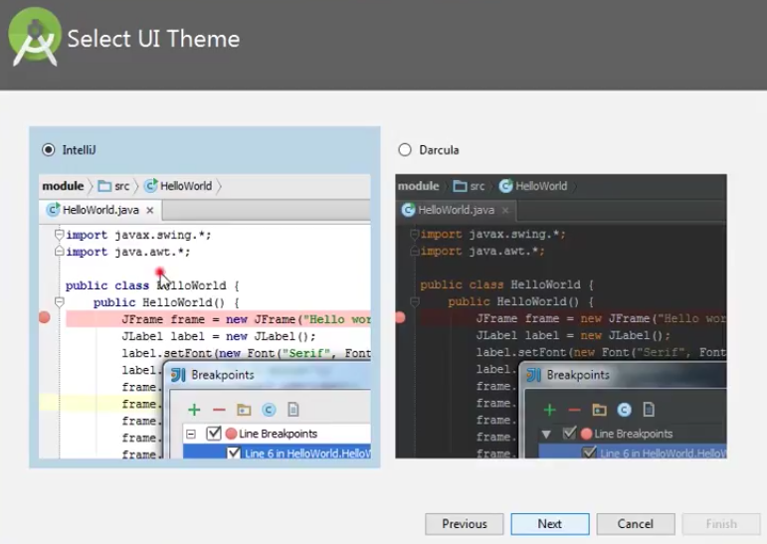

Click on the **Next**button.

**Step 8:**Now it is time to download the SDK components.

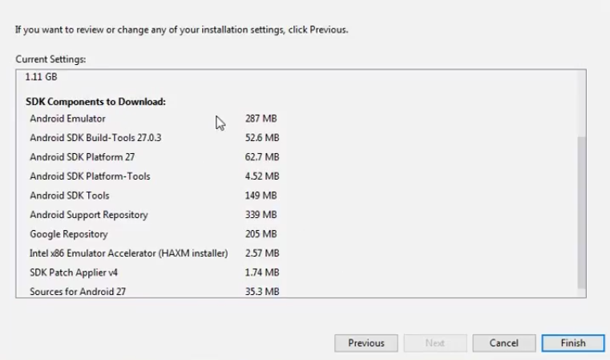

Click on Finish. Components begin to download let it complete.

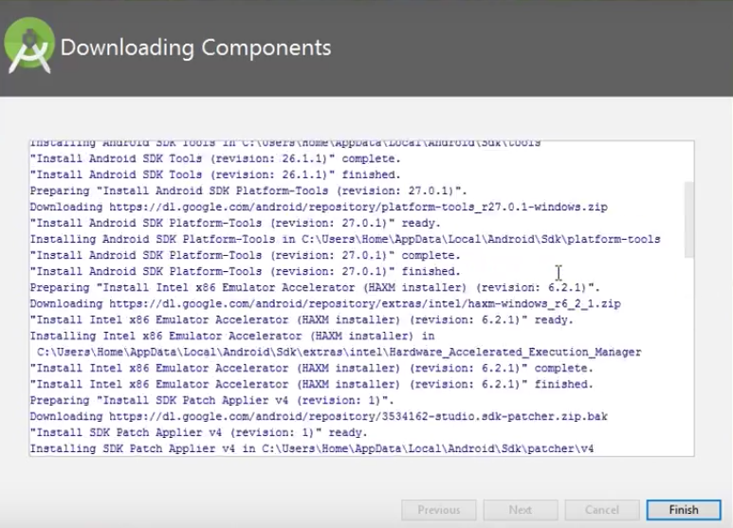

The Android Studio has been successfully configured. Now it’s time to launch and build apps. Click on the Finish button to launch it.

**Step 9:**Click on **Start a new Android Studio project** to build a new app.

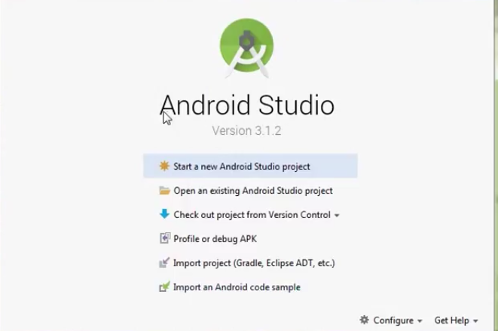

b) In android development, we need an android device to run the application. So, developers of Android Studio provide an option to install android virtual device to run it. In this article, we will learn how to install Android Virtual Device (AVD).

Follow the below steps to install **Android Virtual Device**.

**Step 1:** Go to **Tools** > **AVD Manager**.

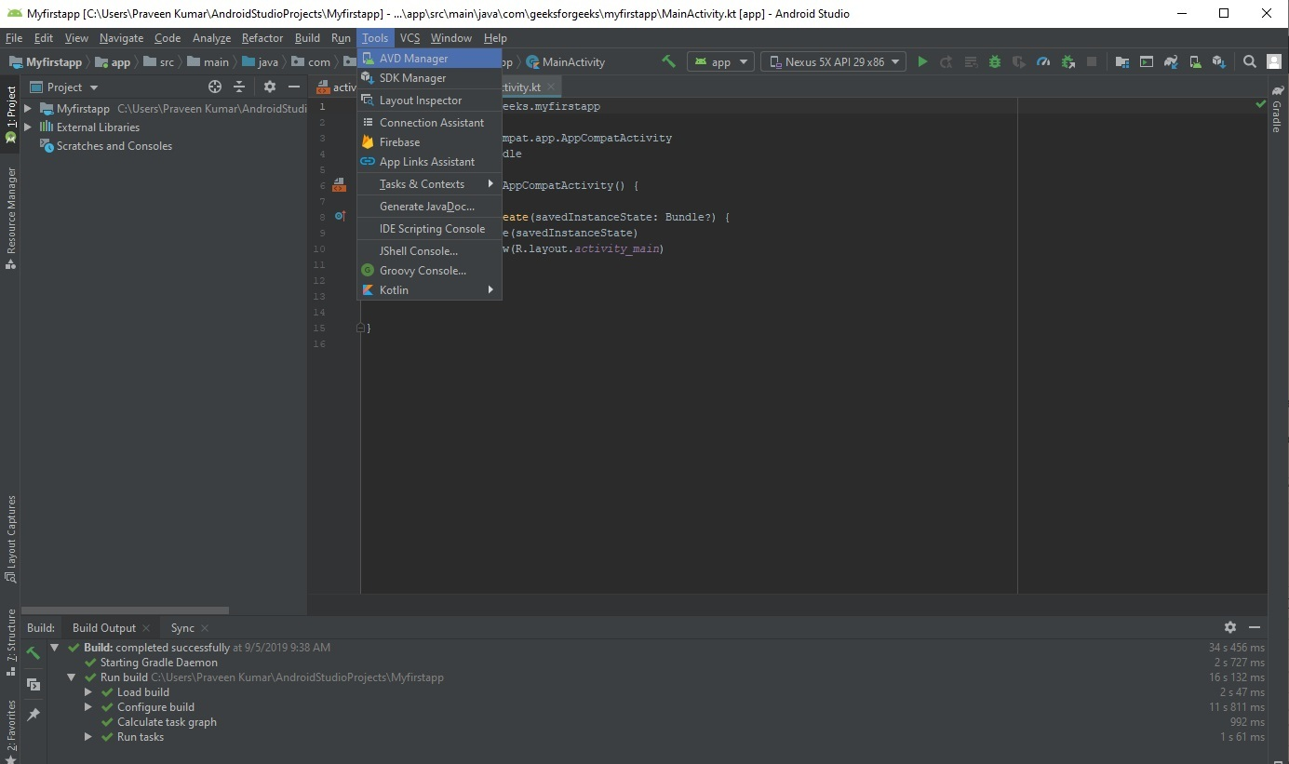

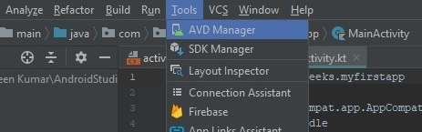

**Step 2:** Now click on **Create Virtual Device**.

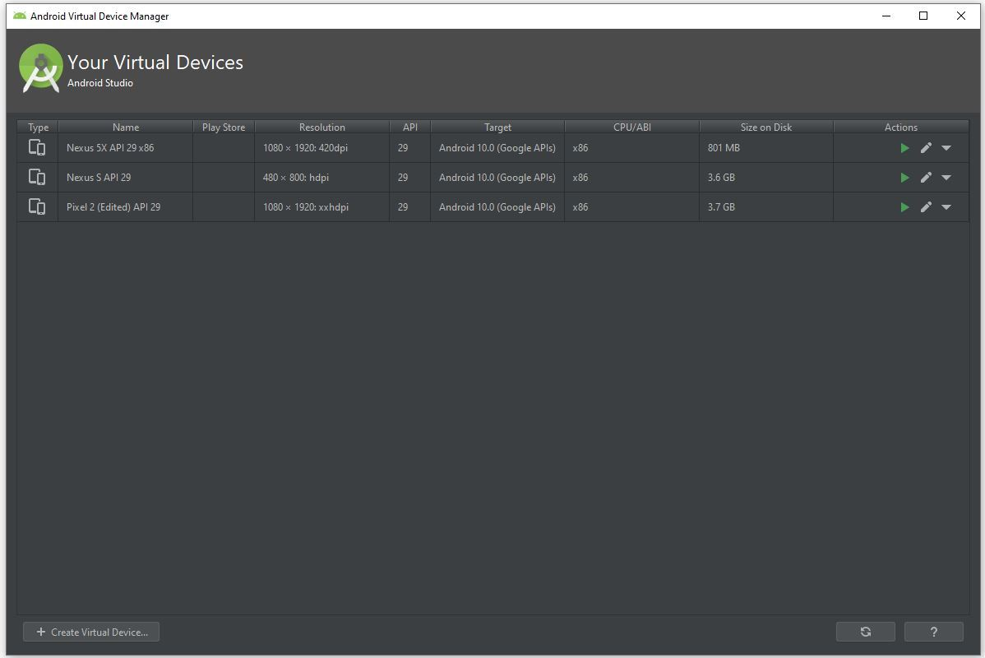

**Step 3:** A pop-up window will be there and here we select the category Phone because we are creating android app for mobile and select the model of mobile phone we want to install.

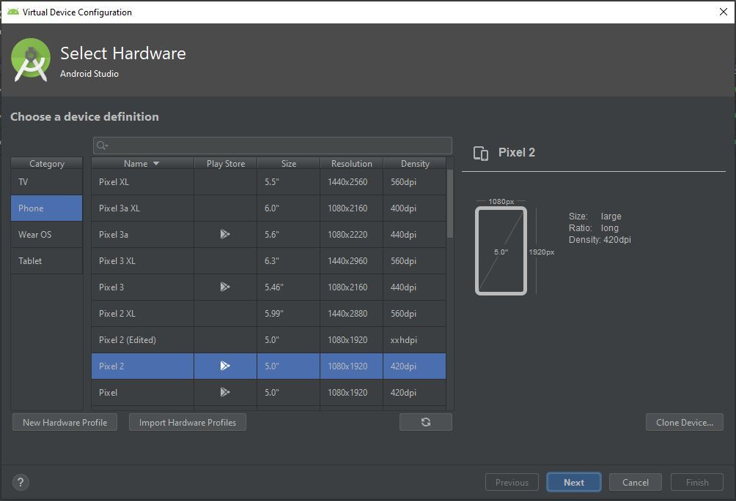

**Step 4:** Here we select the android version to download like **Q**, **Pie**, **Oreo** etc and click **Next** button.

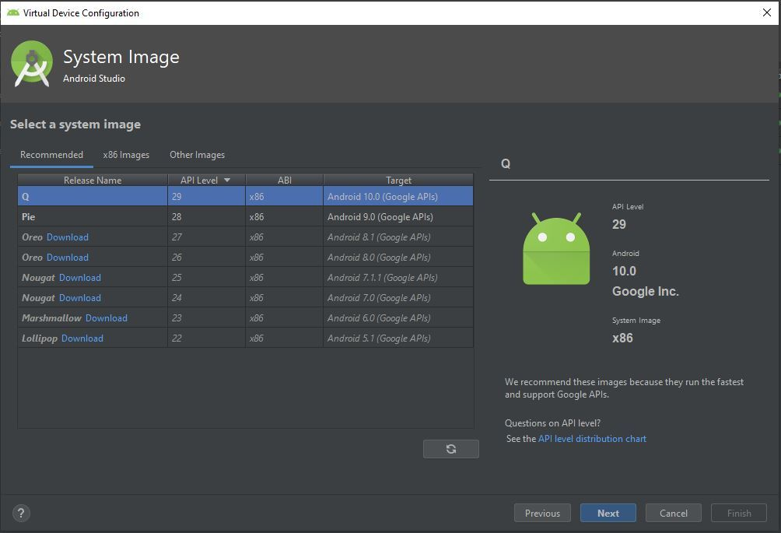

**Step 5:** Click the **finish** button to complete the installation.

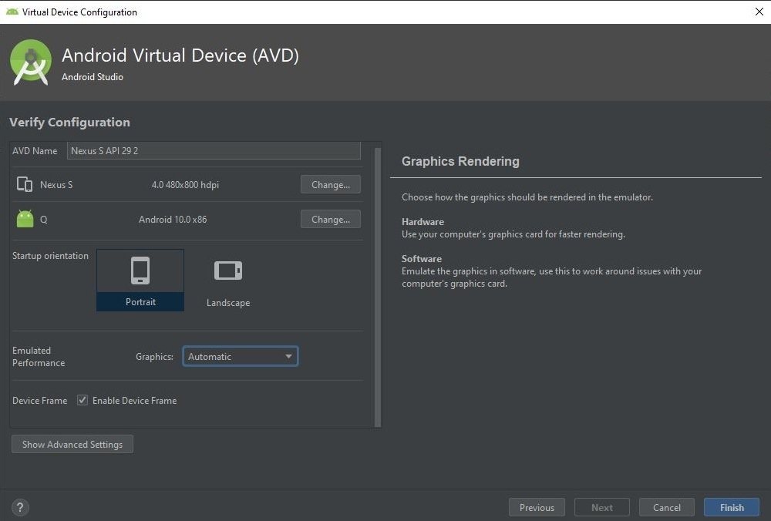

**Step 6:** Now we can select the virtual device we want to run as emulator can click on the **run** icon.

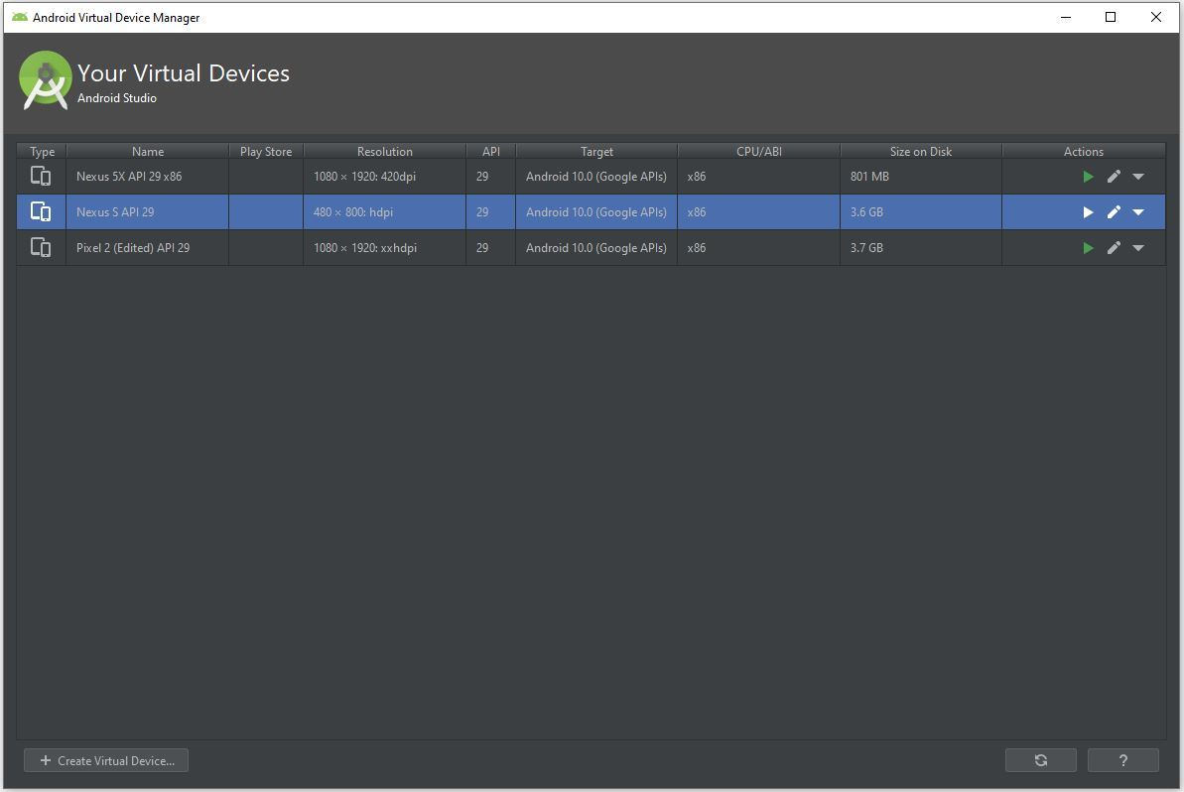

**Step 7:** Finally our virtual device is ready to run our android app.

**Output:**

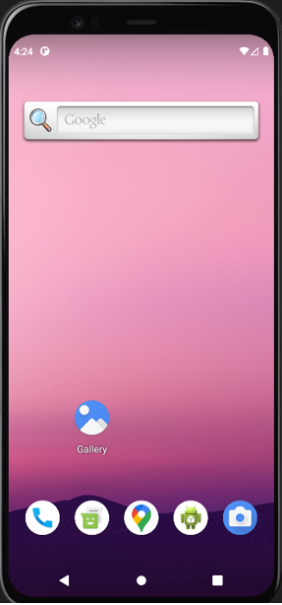

**Result:**

Installation of Andriod studio and creating a virtual device are done successfully